Gig Services Recommendation Method for Fuzzy Requirement Description
Zhiying TU, Xiaofei XU, Qian ZHANG, Hanming ZHANG, Zhongjie WANG
School of Computer Science and Technology, Harbin Institute of Technology, China
e-mail: {tzy_hit, xiaofei}@hit.edu.cn, helen_zhang_hit@outlook.com, sunfiyes@163.com, rainy@hit.edu.cn

Abstract—In recent years, freelancer economy has been a new normalcy. In the supply-driven freelancer marketplace, people sell their capabilities or labor as service on the internet platform to help others with some particular micro-tasks. As this kind of human service ecosystem is at the fast growth stage, it is inundated with a variety of services whose quality is uneven. Quite often, when facing these services, customers hesitate to make the decision. The root causes of this hesitation are: (1) customers do not know these services well, even the explicit service category and description are provided; (2) customers do not know their own demands well. Most of the time, customers only have a general/fuzzy goal, but have no sense of the requirements in detail. Therefore, this study aims at proposing a human services recommendation method for fuzzy customer requirement. The experimental data of this study is collected from Fiverr.com, which is one prominent supply-driven human services marketplace. By analyzing the transaction data, any details of services, freelancers, customers, and their relations will be extracted to construct a supply-demand relation graph. In this study, customer’s fuzzy requirement description will be transferred into a query subgraph, which is the input of an evolved subgraph matching algorithm. This algorithm will help to retrieve the recommendable services (combinations). In addition, a guided Q&A approach is designed to complement customer’s fuzzy requirement, so that subgraph matching algorithm can retrieve better results.
Keywords-Human services; service recommendation; fuzzy requirement; knowledge graph; subgraph matching

Introduction
In recent years, crowdsourcing systems are becoming more and more popular. Because they can help people to accomplish some particular micro-tasks that they are not familiar with or specialize in. Freelancers, who are the backbone of these systems, sell their capabilities or labor as a service (so called human services) [1]. Nowadays, the social phenomenon of temporarily employment in crowdsourcing human service marketplace has become a new economical normalcy. The Bureau of Labor Statistics estimates that more than 30 million people now work as independent professionals in the United States alone [2].
There are two types of crowdsourcing human service marketplaces, which are demand-driven and supply-driven [3]. This study focuses on the supply-driven market. In supply-driven marketplaces, workers (suppliers) advertise their skills and special talents with the hopes of differentiation from each other (e.g. “I will convert your idea into Android, iOS, and web, starting at $10”), and requesters will choose their favorite one from a list of services.
We have made a six months long investigation in Fiverr.com (one prominent supply-driven human services marketplace and one of the 100-most popular sites in the US and one of the 200-most popular sites in the world [2].) This site is at the fast growth stage. It has millions of registered users. It has listed more than 3 million gig services (human services in Fiverr.com) that belong to 9 primary categories and 103 secondary categories. The gig services resource is abundant, but honestly, the quality of these gigs is uneven. Quite often, when facing these gigs, customers hesitate to make the decision. The root causes of this hesitation are: (1) customers do not know these gigs very well, even the explicit service category and description are provided; (2) customers do not know their own demands well. Most of the time, customers only have a general/fuzzy goal, but have no sense of the requirements in detail. As mentioned, people turn to these crowdsourcing systems, because they are not specialize in what they have to accomplish. For example, someone wants to build a website for his company, but he has no idea how to build it. After he clicks the category of “Mobile Apps & Web”, he may get lost in reading the descriptions of the listed gigs. What are the differences between Apps and Web? What is Java, Python? How long the project will take? Is $30 a reasonable price? With these confusions, he may make a pretty bad decision.
Actually, Fiverr.com has many ways to recommend “best gigs” to the customers. However, are these best gigs the most suitable one for each customer? Can customers get rid of a mass of description texts? Can customers describe their requirements better and clearer? Does one gig can fulfill the needs? To answer these questions, we make the following contributions in this manuscript:
- Analyzing the transaction data to extract any details of services, freelancers, customers, and their relations, which will be used to construct a supply-demand relation graph (SDRG).
- Transferring customer’s fuzzy requirement description into a query subgraph, which is the input of an evolved subgraph matching algorithm. This algorithm will help to retrieve the recommendable services (combinations).
- Complementing customer’s fuzzy requirement via a guided Q&A approach, so that subgraph matching algorithm can retrieve better results.
This paper is organized as follows: section II explains the definitions of isomorphic graph, query subgraph, and their relations with service retrieval; section III introduces the proposed method of gig services recommendation for fuzzy customer requirement description (GSR4FR); section IV illustrates the experiments to show the validity of our approach.

Preliminary & Problem Definition

Construction of Supply-Demand Relation Graph
Essentially, the SDRG defined in this study is a labeled graph G = (V_{G}, E_{G}, L_{G}). It has a node set V_{G}, an edge set E_{G}, and a label set L_{G}. each node u ∈V_{G} is attached with a set of labels that is denoted by L(u) ⊆ L_{G}. The edge set E_{G} ⊆ V_{G}×V_{G} contains all the pairs of two nodes, who are correlated. Each edge e ∈E_{G} has an attribute called R, which is used to note correlation type.
In this study, we define gigs, customers, freelancers, and their properties (such as gig’s category, customer’s age, freelancer’s skills, and so on) as nodes. The numeric values and semantic descriptions of these nodes are the labels. The relationships among these nodes are assigned to the e.R of edges. For instance, gig “belongs to” category, freelancer “provide” gig, gig A “frequently association with” gig B, and so on.

Subgraph Matching
In this study, customer’s fuzzy requirement description will be transferred into a query subgraph Q = (V_{Q}, E_{Q}, L_{Q}), which has a query node set V_{Q} with a query label set L_{Q}, and an edge set E_{Q}. For example, a customer needs to “create a business brochure within $10”. Then, we will extract the keywords from this demand, and build a query subgraph that consists of a “gig” node with label: “create a business brochure”, a “price” (property) node with label: “$10”, and an edge with relation: “worth”.
This study aims at matching the query subgraph with the SDRG to find the top-N isomorphic subgraphs, which represent the recommendable gigs.
Generally, the subgraph isomorphism is defined as an injective function f: V_{G} →V_{G’}, s.t., (1) ∀u ∈V_{G}, L(u) ⊆ L(f(u)), and (2) ∀(u, v) ∈E_{G}, (f(u), f(v)) ∈E_{G’}. In this study, the f is a comprehensive matching cost function, which adds up the costs of matching a query node with its candidate, thereby capturing the difference between labels and neighborhood structures of the two nodes (see part C of section III).

Semantic Matching
As mentioned above, subgraph matching has to compute the labels’ similarity. Meanwhile, most of the labels are semantic descriptions. Therefore, this study chooses Locality Sensitive Hashing (LSH) algorithm to deal with this issue. LSH is one the most popular approximate nearest neighbor algorithms. It can find the most similar topics from the massive high-dimensional data. LSH hashes input items (n-dimensional) so that similar items map to the same “buckets” with high probability. The number of buckets is much smaller than the universe of possible input items. The hash function must obey the following conditions:
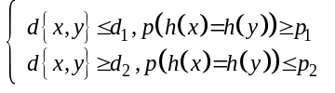 (1)
d(x, y) is the Euclidean distance between two items. p is the probability function. h(x) is the LSH hash function (as shown in equation (2) ).
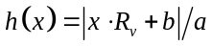 (2)
R_{v} is a random vector; a is the width of the “bucket”, b is random variable that is evenly distributed in [0, a]. 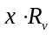is a projection from vector x to R_{v}.

GSR4FR method
Fig 1 illustrates the proposed framework of gig services recommendation method for fuzzy requirement description, which consists of three major parts: input data, offline process, and online process.
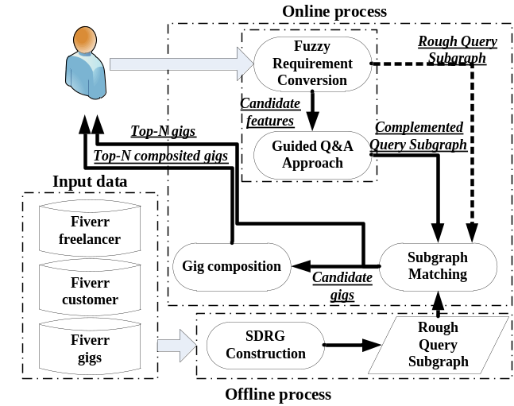
Fig 1. The framework of GSR4FR method

Input data
Fiverr does not provide an API for programmatically querying for information regarding freelancers, customers and gigs, thus, a crawler was developed to collect data for this study. The input data includes:
- Freelancer information: includes seller’s nickname, description, language, country, skills, certification, the provided gigs, and so on.
- Gig information: includes gig’s title, description, price, tags, rating, review count, favorite, and so on.
- Customer information: includes customer’s nickname, country, description, languages, register date, and so on.
- Customer comment: includes customer comment and rating after purchasing, and the seller’s reply for each comment. (Note: customer can post a comment only when he/she purchases a gig. Thus, a comment equals to a transaction log. )

Offline process – Construction of SDRG
The main task of the offline process is to analyze the transaction data to extract any details of gigs, freelancers (sellers), customers, and their relations, which will be used to construct a supply-demand relation graph (SDRG). The types, “freelancer”, “customer”, “gig”, are the essential types of nodes in SDRG. Both “freelancer” node and “customer” node use the nickname as their label. “gig” node uses its title as its label.
This study also extracts the properties of gigs, freelancers, and customers as the nodes. Table I shows the examples of these property nodes and their labels.
- Examples of these property nodes and their labels
Gig’s property nodes | Label example | Seller’s property nodes | Label example
Faviourites | 1000 | Country | China
Keywords (tags) | Java, web | Language | Chinese & English
Create time | 2010-10-01 | Education | X university
Develiery time | 3 days | Certification | Engineering Master
Lowest price | $5 | Skills | Programming
Highest price | $100 | Seller level | 2
Root category | Program-  ming&tech | Average response time | 24 hours
Sub-category | WordPress  service | Seller longevity | 5 years
For the sake of avoiding making the SDRG too complex to use, this study manually defines several relations and assigned to the edges. Table II shows the examples of these relations.
- Examples of relations between nodes
Node_Type_1 | Relation R | Node_Type_2
Customer | Buy | Gig
Freelancer | Provide | Gig
Sub category | Belong | Root category
Gig | Sub-belong | Sub-category
Freelancer | Speak | Language
Freelancer | Located | Country
Freelancer | own | Seller level
Gig | Strongly associated | Gig
Gig | Relevantly associated | Gig
Gig | Weakly associated | Gig

Online process
The online process has three main tasks: fuzzy requirement conversion, subgraph matching, and gig composition.

Fuzzy requirement conversion
This is the first step of the GSR4FR method. It intends to understand the semantic description of user requirement, and transfer it into a query subgraph. As the output of this phase, query subgraph is used to retrieve the top-N recommendable gigs from the SDRG. As mentioned above, in this research scenario, the requirement is fuzzy. It means that it only has a general goal and very a few details (e.g. “create a business brochure within $10”). There are two solutions for converting this kind of fuzzy requirement into query subgraph.
One solutions is that, we can use the LDA based topic extraction method proposed in [4, 5] to extract the keywords/key phrases to construct a simple query subgraph (“gig: create business brochure”->“worth”->“price: $10”, as shown in the left of Fig 2.). This kind of simple subgraph is also called “rough query subgraph”, which can be used directly in the subgraph matching phase (as the dotted arrow shown in Fig 1). However, the experiment result shows that the performance of subgraph matching method based on rough query subgraph still needs to be improved. We will discuss this in detail in section IV.
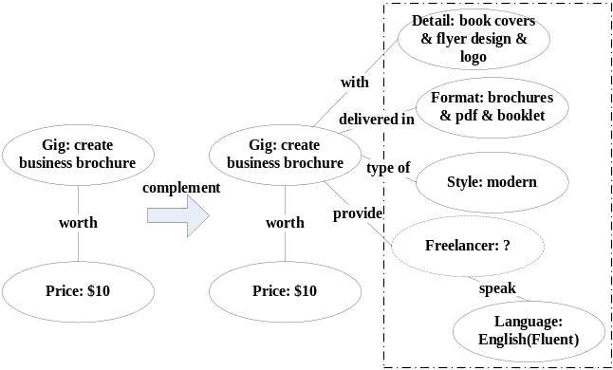
Fig 2. Example of rough query subgraph and complemented query subgraph
Another solution is to get more precise information to complement the query subgraph. Therefore, a Guided Q&A approach is adopted to acquire more details of consumers’ potential demands.
Firstly, LSH (Locality-Sensitive Hashing) method is used to compute the semantic similarity between the consumer’s fuzzy input and the title of each gig service in the SDRG. The gig’s title is the brief description of this service. Thus, we believe that consumer’s ideal gigs are within the outputs of this LSH method. Top-N of LSH outputs are selected as the “candidate gigs”.
Secondly, based on the “candidate gigs”, all the properties of these gigs will be extracted and classified. So that, these properties and their labels can be the “candidate features” for requirement complement in the Guided Q&A phase (as shown in Fig 3). In this way, customer does not need to read the gig description to know the details. By clicking these options, he/she can get a complemented query subgraph for the next step (as shown in the right of Fig 2).
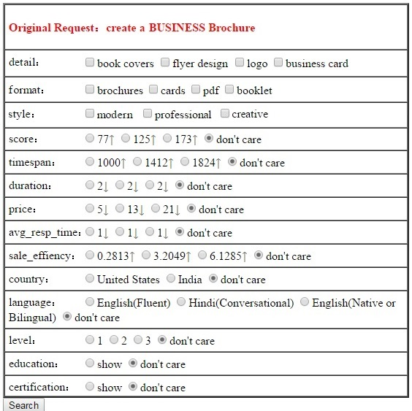
Fig 3. Example of Guided Q&A approach

Subgraph matching-recommendable gigs retrieval
In this study, a neighborhood-based subgraph matching algorithm [6, 7] is adopted to retrieve the isomorphic graph. As mentioned in the part B of section II, this method takes both the differences between labels and neighborhood structures of the two nodes into account. The pseudocode of the algorithm is shown as follows:
Subgraph matching algorithm
Input: Target graph G(V, E, L), Query Graph Q(V_{Q}, E_{Q}, L_{Q}).
Output:Top-N Minimum cost matching of Q in G.
1. for each node v ∈ V_{Q}
2. compute M(v);
3. i := 0; flag := true;
4. while flag do
5. i := i + 1;
6. for each v ∈ V_{Q} do
7. for each u ∈ M(v) do
8. compute U_{i}(v, u);
9. note the current matches of neighbors v’ ∈ N(v);
10. compute optimal match O_{i}(v)
11. if O_{i}(v) = O_{i-1}(v) then
12. put v into a temp set of query nodes TV_{Q}
13. if the size of TV_{Q} is more than a threshold number then
14. flag := false;
15. construct Φ for all v∈V_{Q}
16. return Φ;
- M(v) is the set of nodes that are matched with v∈ V_{Q} by obeying the following conditions:
- ∀ u∈M(v), u∈V
- u∈M(v) has the same type with v.
- for u∈M(v), if ∆(u, v) > σ, u is a candidate node that may match with v. ∆(u, v) means the label similarity of node u and v, which is either semantic similarity or numerical approximation. σ is a threshold value, it could be the different for semantic similarity and numerical approximation.
- We define an injective function , which has (v) = u, v∈ V_{Q}, u∈M(v).
- N(v) is the set of neighbor nodes of node v. It means that the distance of u∈N(v) and v must be smaller than h hops. h is a threshold value.
- U_{i}(v, u) is the matching cost of nodes u and v after i^{th} iterations. It is designed as equation (3).
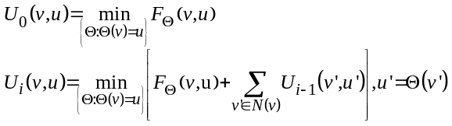 (3)
- F_{ʘ} is the function for computing matching cost (defined as equation (4)), which includes neighbor structure matching cost and label matching cost.
(4)
Where, u =(v); the optimal value of λ lies between 0.3~0.5 empirically;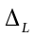is the function that calculate the label similarity, v, which is either semantic similarity or numerical approximation. If label is a semantic description, then it will use LSH to calculate the. Otherwise, it will use subtraction to do it.
N_{ʘ} is the function for computing neighbor structure matching cost. It is designed as equation (5).
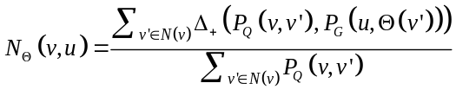 (5)
Where P_{Q}(v,v’) denotes the proximity of v’ from v in Q (the same definition for P_{G} function).
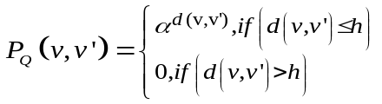 (6)
is a parameter with value in (0, 1). d(v,v’) means the distance between node v and v’. It must be not more than h hops, which is the radius of the neighborhood vector of v∈ V_{Q}. 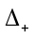(x,y) is a function defined as equation (7).
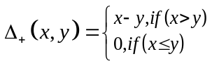 (7)
- O_{i}(v) represents the minimum matching cost value of every u∈M(v) and v. It is designed as equation (8).
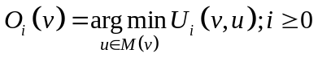 (8)
- Φ is the final set of matched subgraphs that will be return. Each subgraph represents a gig service, which maybe a candidate for recommendation. In order to give the best recommendation, we sort these matched gigs by gig’s quality, which is defined as equation (9). We use gig’s quality instead of the gig’s rating that is provided by Fiverr.com, because the gig’s rating is badly unbalanced. More than 90% of gigs have high rating (> 4.5). After the sorting, we will select the Top-5, Top-10, or Top 20 to recommend.
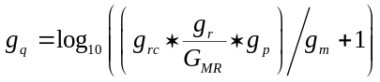 (9)
Where, g_{r} is gig rating (range from 0 to 5, with the interval of 0.5 ); G_{MR} is highest rating (5 points); g_{q} is gig’s quality (continuous numeric); g_{rc} is gig’s review count; g_{m} is gig’s longevity; g_{p} is gig’s price.

Gig composition
Up to now, we are discuss about how to deal with the fuzzy requirement implicating only one gig requirement. However, most of the time, customer’s fuzzy requirement may have more than one gig requirement hiding inside. For example, the expression of “I need to create a business brochure and a website” implicate two gigs requirements: “create business brochure” and “create website”. We can use the method mentioned above to retrieve the Top-N recommendable gigs for each gig requirement. However, how to pick up two gigs from two sets of candidate gigs for the composition? Which is the best combined gigs? Thus, this study proposes a gig composition method.
To identify the priority of the recommendable gigs combination, we make a data-driven investigation on the transaction data. This investigation aims at discovering the frequent association among the existing gigs. Unfortunately, among the massive gigs, the frequently associated ones are barely found. Thus, we perform the FP-growth algorithm on the gig’s root categories, gig’s sub-categories, and gig’s tags. The experiment result shows that: (1) under all the categories, the # of gigs with each frequent purchasing sequences are, in order, “with frequent tags”, “within the same root category”, “with frequent root category”, “under irrelevant categories”; (2) under the same sub-category, the # of gigs with each frequent purchasing sequences are, in order, “with frequent tags”, “with frequent sub-category”, “under the same sub-category”, “under irrelevant sub-categories. Based on these results, a priority model is designed for gigs composition.

Priority model for gigs composition
Based on the experimental results mentioned above, a priority hierarchical structure of the influencing factors of combined gigs recommendation is built as Fig 4 shows. We will use the accumulated impact values, which are attached to 9 leaf nodes of this tree model, to represent the 9 priority levels for gigs composition options.
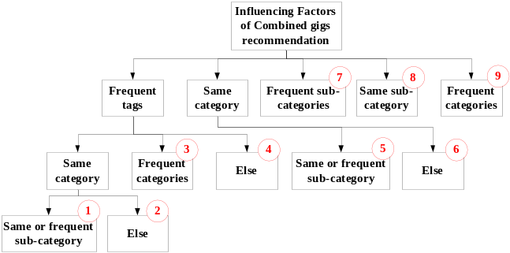
Fig 4. Priority hierarchical structure for the influencing factors of combined gigs recommendation
In this hierarchical structure, the elements in each layer can use the elements in the upper layer as the comparative criteria to do the comparison with other elements in the same layer. For instance, both gig X and gig Y have “frequent tags” (one of the element in upper layer), but X has higher priority than Y. Because, X is the gig in the “same category”, but Y is the gig in the “frequent categories”. This is a comparison between the elements in the same sub-layer of “frequent tags”.
In this way, we can define a discriminate matrix A=(a_{ij}) for comparison of elements in the same level. a_{ij} is an integer from 1 to 9, or its reciprocal. The rule to assign the value to a_{ij} is defined as follows:
- a_{ij} = 1, if i^{th} element is as important as j^{th} element. Identically, a_{ji} = 1.
- a_{ij} = 3, if i^{th} element is weakly more important than j^{th} element. On the contrary, a_{ji} = 1/3.
- a_{ij} = 5, if i^{th} element is relevantly more important than j^{th} element. On the contrary, a_{ji} = 1/5.
- a_{ij} = 7, if i^{th} element is strongly more important than j^{th} element. On the contrary, a_{ji} = 1/7.
- a_{ij} = 9, if i^{th} element is extremely more important than j^{th} element. On the contrary, a_{ji} = 1/9.
For example, the elements in second layer are A₁ (“frequent tags”), A₂ (“same category”), A₃ (“frequent sub-categories”), A₄ (“same sub-category”), and A₅ (“frequent categories”). We construct a discriminate matrix A²=(a_{ij}) for them (as shown in table III).
- Example of a discriminate matrix for one layer
 | A₁ | A₂ | A₃ | A₄ | A₅
A₁ | 1 | 3 | 5 | 7 | 9
A₂ | 1/3 | 1 | 3 | 5 | 7
A₃ | 1/5 | 1/3 | 1 | 3 | 5
A₄ | 1/7 | 1/5 | 1/3 | 1 | 3
A₅ | 1/9 | 1/7 | 1/5 | 1/3 | 1

Single hierarchical arrangement & consistency verification for priority computation
Based on this priority hierarchical structure and the discriminate matrixes, this study uses single hierarchical arrangement and consistency verification to calculate a reasonable and accurate priority weight for each node in one layer of the priority hierarchical structure [8].
Each discriminate matrix A=(a_{ij}) has a characteristic equation: . is the largest eigenvalue of this characteristic equation.is the corresponding eigenvector. To do the normalization for , the vector achieved is the priority weight of each element in this layer. This process is a single hierarchical arrangement. In order to avoid an extreme case of round-robin comparison (e.g. element a is more important than b, element b is more important than c, element c is more important than a), consistency verification is very necessary. For each layer, consistency ratio CR must be calculated for consistency verification.
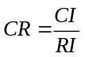 (10)
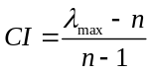 (11)
Where, CI is the consistency indicator; n is the matrix order of the discriminate matrix (# of elements in one layer); RI is the average random consistency indicator (table IV shows the statistical values of RI with n). If consistency ratio CR < 0.1, then the result of single hierarchical arrangement has consistency. Otherwise, the value of a_{ij} needs to be adjusted.
- The statistical values of RI with different matrix order
ｎ | 1 | 2 | 3 | 4 | 5 | 6 | 7 | 8 | 9
RI | 0 | 0 | 0.58 | 0.90 | 1.12 | 1.24 | 1.32 | 1.41 | 1.45

Taking the discriminate matrix shown in table III as an example, after the single hierarchical arrangement, we can get the as follows:
- Final Priority of the influencing factors for combined gigs recommendation
Name | 1 | 2 | 3 | 4 | 5 | 6 | 7 | 8 | 9
Frequent keywords | √ | √ | √ | √
Same category | √ | √ |  |  | √ | √
Same subcategory | √ |  |  |  | √ |  |  | √
Frequent subcategory | √ |  |  |  | √ |  | √
Frequent category |  |  | √ |  |  |  |  |  | √
Weighs | 0.2564 | 0.2288 | 0.1956 | 0.1125 | 0.0959 | 0.0682 | 0.0240 | 0.0129 | 0.0055
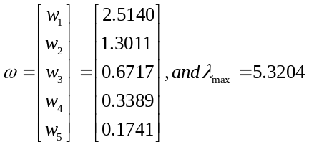
So, CI = 0.0801. According to table IV, when n = 5, RI = 1.12. Thus, CR = 0.07 < 0.1. It means that the assignment of each a_{ij} of the discriminate matrix A² is reasonable. To do the normalization forby equation (12), we can get a vector PR that consists of the priority weigh of each element in the second layer. PR is shown as follows:
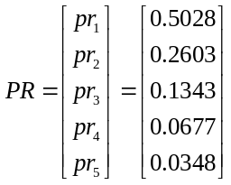
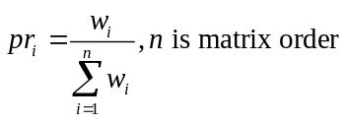 (12)
Finally, we make a weighted superposition of each node in the priority hierarchical structure shown in Fig 4. This superposition must obey the “father and son” relation of this tree model. After this superposition, we will perform normalization the accumulated value of each leaf node (av_{i}) on this tree model by using the equation (13). Afterwards, we will get the final priority of the influencing factors (fpr_{i}) on the leaf nodes (as shown in table V), which will be used for combined gigs recommendation.
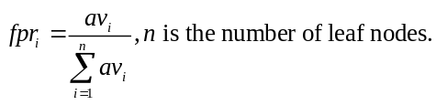 (13)
For instance, gigs, with “frequent tags” and under the “same sub-category” or “frequent sub-categories”, have weighted priority 0.2564 to be combined together. For the sake of simplicity, this study reduces these 9 priority levels into 3 levels by classified by the equation (14).
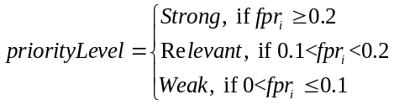 (14)
If two candidate combined gigs have the same priority level, then the original fpr_{i} and gig’s quality will be used to sort them.

Experiments

Dataset Description
We developed a crawler to collect the data of gigs, sellers, and comments from Fiverr platform. We ran the crawler for six months – from July 2016 to December 2016. Table III shows the detail description of the dataset.
- Details of the dataset
Data Item | Count
# sellers | 3,990
# gigs | 51,638
# gig category | 9
# gig sub category | 103
# comments | 1,389,711
# customer comments | 752,115(54.12%)
# seller reply | 637,596(45.88%)
The properties of gig, customer, and freelancer that are extracted for SDRG construction were described in part A of section III.

Experiment Result of Subgraph Matching
This study randomly picks up data segment with different sizes from the Fiverr dataset, which will be used in a comparative experiment. The minimum data segment has 10000 gigs and the corresponding data that is linked by gig transaction. The size of data segment will be gradually increased by adding 5000 gigs. The two solutions mentioned in part C of section III, one with guided Q&A method and one without, are performed on these different data segments. Fig 5 shows the comparative experiment results of these two solutions, which indicate their average time-consuming performances on data segments in different sizes.
This experiment result indicates that using the rough query subgraph to retrieve the Top-N recommendable gigs costs longer time than using the complemented query subgraph. Besides that, when the size of data segment becomes bigger, its time cost increases much quicker as well.
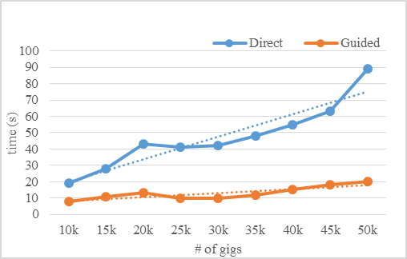
Fig 5. Average time-consuming performances on different sizes of data segments
We also compare the Top-N recommendable gigs that are generated by these two solutions. As shown in fig 6, when the size of data segment becomes bigger, the size of Top-N gigs of the solution with rough query subgraph has a significantly growth. However, the performance of the solution with complemented query subgraph has less growth. In addition, the number of Top-N gigs of the solution with complemented query subgraph is smaller. It means that its answers are more precise and closer to the “Mr. right”.
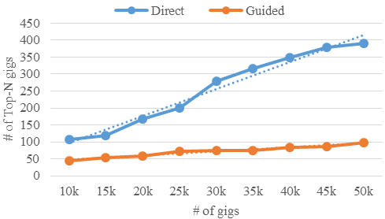
Fig 6. Numbers of Top-N gigs of Different Methods
In addition, we concern the reduction ratios of the two phases of the solution having guided Q&A approach, which can indicate this solution’s performance of compressing searching space. The reduction ratio of first phase (RR_{LSH}) is designed as equation (15). The reduction ratio of second phase (RR_{Q&A}) is designed as equation (16).
 (15)
 (16)
The experiment result in fig 7 shows that the candidate gigs retrieved by LSH method in first phase is less than 8% of total gigs in data segment. When the size of data segment becomes bigger, the proportion gradually reaches a stable value around 3%. In any case, LSH method cuts off the vast majority of dissimilar gigs. However, there are still many dissimilar gigs in the candidate gigs, because RR_{Q&A} reaches proportion between 5.5% and 7.1% (as shown in fig 7).
Up to now, you may have a question: “Do these two rounds of compressions with big proportion cut the right answers off?”. The answer to this question is “No”. The average g_{q} (gig’s quality) of top-20 gigs is between 3.12 and 3.2. (Note: the gig with g_{q} > 3.5 is a “best gig”.)
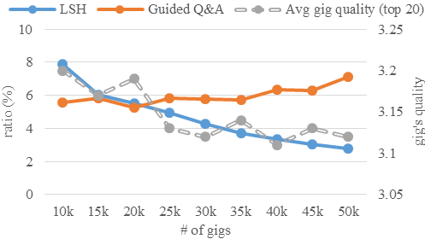
Fig 7. Reduction ratios before and after guided Q&A

Experiment Result of Gig composition
The distribution of priority levels of the combined gigs is the key measurement indicator for this experiment. This distribution, denoted by DPL_{i}, is designed as:
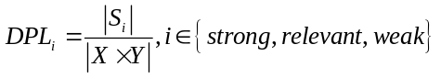 (17)
Where, i represents the priority levels: strong, relevant, and weak; S_{i} means the set of combined gigs that belong to i priority level; X, Y are two sets of candidate gigs retrieved by subgraph matching. denotes the cross join of X and Y.
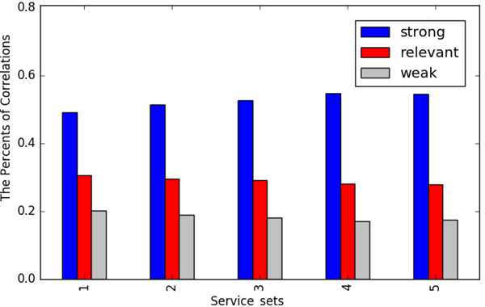
Fig 8. Distribution of priority levels measurements on different data sets
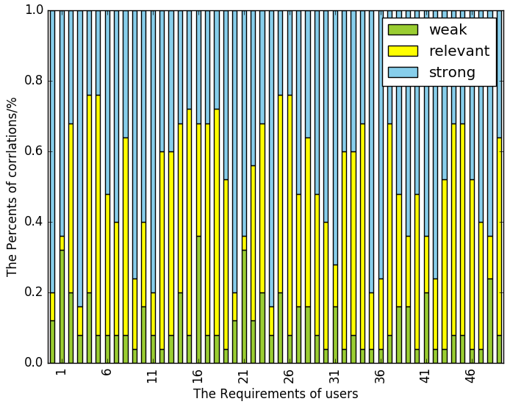
Fig 9. Distribution of priority levels measurements on 50 requirements
Similar to the previous experiment, we design several data segments. The minimum data segment has 10000 gigs and the corresponding data that is linked by gig transaction. The size of data segment will be gradually increased by adding 10000 gigs. And then, we perform respectively the gig composition method on them. Fig 8 illustrates the experiment results. It shows that when the size of data segment becomes bigger, the proportion of the combined gigs in strong priority level will increase a little bit. In average, the distribution of priority levels of the combined gigs is: 58% strong, 23% relevant and 19% weak.
Fig 9 illustrates the distribution of priority levels of the combined gigs on 50 customers’ requirements. It shows that more than 90% recommended combined gigs are either in strong priority level or in relevant priority level.

Related Work

Research of human service ecosystems
There have been several studies on human service ecosystems. [1] investigated the Fiverr crowdsourcing service marketplace and made an empirical study of growth in human service ecosystem. [2] investigated a demand-driven marketplace - MyFreelancer.com, and made a market report about freelancer economy. Some measurement studies on Fiverr were proposed in [3], which focus on the quality of the gigs. [8] characterized the sellers, buyers and the interactions among them, and pointed out the importance of service recommendations in the crowdsourcing website.

Research of subgraph matching
Knowledge graph has become a hot topic in recent years. As subgraph matching is an effective way to retrieve information from large-scale graph, many researchers have contributed on it in the last decade. For example, A. Khan proposed a method for computing the similarity of subgraphs. This method was based on the neighbor structure similarity measurement [6]. Two years later, A. Khan proposed another subgraph matching method by adding the node’s label similarity measurement to the previous method [7]. [10] also proposed a subgraph matching method by using missing edges as a measure of approximate matching quality, but it did not calculate the approximation among tags.

Research of service recommendation
Service recommendation is a classical topic in service computing domain. [4, 5] designed the recommendation method or discovery method based on topic extraction from service description or co-occurrence log. The method introduced in [11] was based on service rating and reputation. [12] paid attention to the context and user preference during service recommendation. The method in [13] was based on the QoS. [14] discussed the applied service recommendation method in industrial scenario. [15] investigated user behavior data of mobile service utilization from mobile app store. The outcome of [15] can be used for recommendation.

Conclusion
This study constructed a supply-demand relation graph (SDRG) based on the clawed data from Fiverr.com. Then, this study has proposed a GSR4FR method that can transfer customer’s fuzzy requirement into a query subgraph. This subgraph is the input of an evolved subgraph matching algorithm. This algorithm was adopted to retrieve the recommendable services (combinations) from SDRG. In order to understand customer better, a guided Q&A approach was adopted to complement customer’s fuzzy requirement.
There are still several open issues left: (1) the relations of edges were only simply used in query subgraph construction; (2) since micro-task does not always need more than two gigs, the services composition here only considered two gigs.

Acknowledgment
Research works in this paper are supported by the National Natural Science Foundation (NSF) of China (No. 61472106) and CCF-Tencent Foundation (No. MH20150586).

References
- K. Huang, J. Yao, J. Zhang, et al. Human-as-a-Service: Growth in Human Service Ecosystem. IEEE International Conference on Services Computing. IEEE, 2016:90-97.
- Y. Hong, P.A. Pavlou. Online Labor Markets: An Informal Freelancer Economy. Social Science Electronic Publishing, 2013.
- H. Ge, J. Caverlee, K. Lee. Crowds, Gigs, and Super Sellers: A Measurement Study of a Supply-Driven Crowdsourcing Marketplace. Proceedings of the Ninth International AAAI Conference on Web and Social Media. 2015: 120-129.
- Q. Wei, Z. Jin, Y. Xu. Service discovery for Internet of things based on probabilistic topic model. Ruan Jian Xue Bao/ Journal of Software, 2014, 25(8):1640-1658
- Z. Gao, Y. Fan, C. Wu, et al. SeCo-LDA: Mining Service Co-occurrence Topics for Recommendation. IEEE International Conference on Web Services. IEEE, 2016:25-32.
- A. Khan, N. Li, X. Yan, et al. Neighborhood based fast graph search in large networks. ACM SIGMOD International Conference on Management of Data, SIGMOD 2011, Athens, Greece, June. DBLP, 2011:901-912.
- A. Khan, Y. Wu, C.C. Aggarwal. NeMa: fast graph search with label similarity. Proceedings of the Vldb Endowment, 2013, 6(3):181-192.
- C. Iyyunni, V. Trivedi, V.S. Anantatmula. An analysis of the process in deriving further benefits of an AHP model. International Symposium of the Analytic Hierarchy Process. 2014.
- S.K. Maity, C.B. Jha, A. Kumar, et al. A Large-scale Analysis of the Marketplace Characteristics in Fiverr. 2016.
- M. Mongiovi, R.D. Natale, R. Giugno, et al. SIGMA: A set-cover-based Inexact graph matching algorithm. Journal of Bioinformatics & Computational Biology, 2010, 8(2):199-218.
- S. Wang, Z. Zheng, Q. Sun, et al. Evaluating Feedback Ratings for Measuring Reputation of Web Services. IEEE International Conference on Services Computing. IEEE, 2011:192-199.
- X. Fan, Y. Hu, R. Zhang. Context-Aware Web Services Recommendation Based on User Preference. Asia-Pacific Services Computing Conference. 2015:55-61.
- M. Silic, G. Delac, S. Srbljic. Prediction of Atomic Web Services Reliability for QoS-Aware Recommendation. IEEE Transactions on Services Computing, 2014, PP(3):425-438.
- L. Chen, J. Wu, H. Jian, et al. Instant Recommendation for Web Services Composition. IEEE Transactions on Services Computing, 2013, 99(4):1.
- H. Li, W. Ai, X. Liu, et al. Voting with Their Feet: Inferring User Preferences from App Management Activities. International Conference on World Wide Web. International World Wide Web Conferences Steering Committee, 2016.

